 | . | SEPTEMBER 9TH, 2023  YOUNG GODS CLOTHING BRAND AND PROUD TO ANNOUNCE OUR PARTICIPATION DURING THIS UPCOMING CYCLE OF NYFW WHICH WILL BE HELD AT GOTHAM HALL ON SEPTEMBER 9TH, 2023  WE ARE CREATING A UNIQUE COLLECTION FOR OUR PARTICIPANTS THAT WILL ALLOW THEM TO SHINE BRIGHT ON THE RUNWAY! OUR GOAL IS TO MAKE OUR MODELS FEEL LIKE STARS! OUR SHOW WILL BE CHIK, EXCITING, SAFE, AND REWARDING. |  | /
ABOUT THE BRAND  YOUNG GODS CLOTHING BRAND WAS FOUNDED EUNIKA SIMMONS AND HER 2 SONS WHO ASPIRED TO CREATE A BRAND THAT WOULD SERVE THE NEXT GENERATION OF GREATS.  WE PRIDE OURSELVES ON BEING ABLE TO CREATE FASHION RELATED EXPERIENCES THAT EMPOWERS, INSPIRES, FURTHER ACTIVATES THE INNER DREAMER.  WE USE FASHION AS A TOOL WHILE DESIGNING UNIQUE CLOTHES THAT GIVES OUR CLIENTS THE OPPORTUNITY TO EXPRESS THEIR INNER STARLIGHT. |  |  |  | 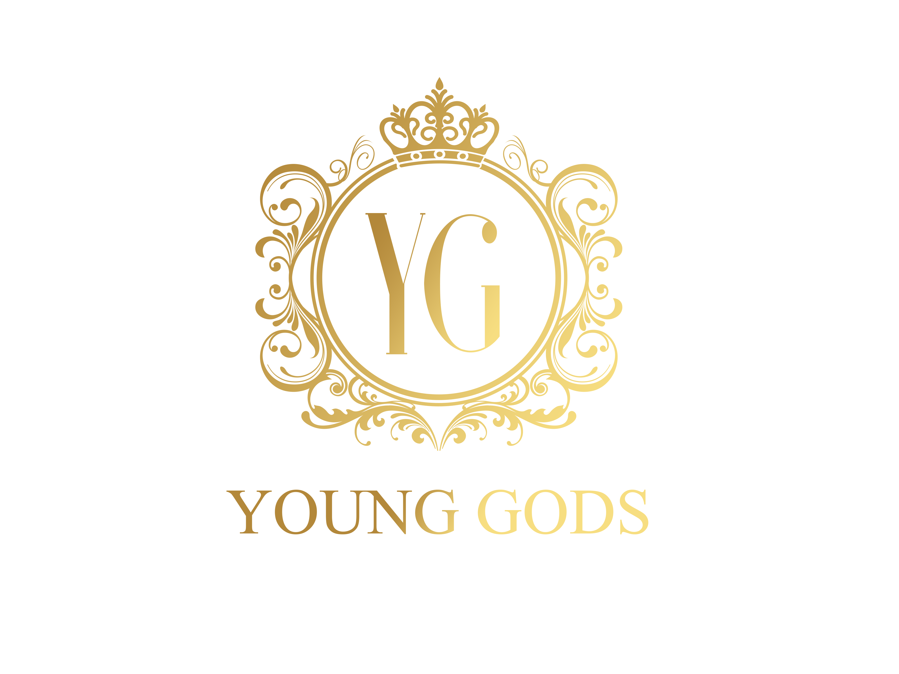  YOUNG GODS CLOTHING BRAND  WWW.YOUNGODZ.COM

AFTER THE MODEL IS REGISTERED WE WILL NEED THE FOLLOWING
- FULL NAME OF MODEL
- PHOTO OF MODEL
- DRESS/CLOTHING SIZE
- 1 PARAGRAPH BIO OF MODEL
- CONTACT INFORMATION
- LIST OF MODEL’S HOBBIES

REGISTRATION
OUR REGISTATION FEE IS $500 WHICH COVERS (package 1)
NYFW RUNWAY SHOW: SEPT. 9TH, 2023
1 LOOK, STYLING, HAIR, MAKE-UP, PHOTOS FROM RUNWAY, PROMOTION, AND PHOTO SUBMISSION FOR MAGAZINES
NYFW PHOTO SHOOT: SEPT. 8TH, 2023
1 LOOKS, STYLING, HAIR, MAKE-UP, EDITED PHOTOS, MAGAZINE SUBMISSION, FEATURE ON WEBSITE/SOCIAL MEDIA, AND TOP QUALITY EXPERIENCE PLUS EXPOSURE TO FASHION INDUSTRY PROFESSIONALS-4 edited photos

MODELS ARE REGISTERED ON A FIRST COME FIRST SERVE BASIS. SPACE IS LIMITED!

TO REGISTER USE THE PAYMENT SOURCE

